Evaluation Report

Contents

Introduction 1

Setup 2

Analysis 2

Appendix 3

# Introduction

This report covers our analysis on the performance of our proposed system against others devised from other research papers.

# Research paper 1 (Yucular et al.)

|  |  |  |  |  |  |  |
| --- | --- | --- | --- | --- | --- | --- |
| **Dataset** | AUC Score Results from Yucular et al. | | | | | |
| LR | NB | MLP | RF | ROT | VOT |
| CM1 | 0.730 | 0.658 | 0.734 | 0.723 | 0.771 | 0.741 |
| JM1 | 0.713 | 0.679 | 0.690 | 0.718 | 0.729 | 0.721 |
| KC1 | 0.670 | 0.780 | 0.916 | 0.812 | 0.87 | 0.757 |
| MC2 | 0.723 | 0.700 | 0.690 | 0.699 | 0.74 | 0.758 |
| PC1 | 0.809 | 0.650 | 0.723 | 0.813 | 0.859 | 0.842 |
| PC3 | 0.823 | 0.756 | 0.780 | 0.795 | 0.827 | 0.792 |

# Setup

# Results (Without Feature Selection Algorithms)

|  |  |  |  |  |  |  |
| --- | --- | --- | --- | --- | --- | --- |
| **Dataset** | AUC Score Results of our Algorithms | | | | | |
| LR | NB | MLP | RF | ROT | VOT |
| CM1 | 0.638 | 0.667 | 0.501 | 0.784 | 0.708 | 0.737 |
| JM1 | 0.65 | 0.621 | 0.584 | 0.66 | 0.613 | 0.647 |
| KC1 | 0.633 | 0.64 | 0.638 | 0.618 | 0.568 | 0.644 |
| MC2 | 0.533 | 0.525 | 0.254 | 0.559 | 0.603 | 0.538 |
| PC1 | 0.827 | 0.78 | 0.479 | 0.854 | 0.773 | 0.841 |
| PC3 | 0.831 | 0.778 | 0.513 | 0.837 | 0.775 | 0.839 |

# Results (Correlated Feature Selection)

|  |  |  |  |  |  |  |
| --- | --- | --- | --- | --- | --- | --- |
| **Dataset** | AUC Score Results of our Algorithms | | | | | |
| LR | NB | MLP | RF | ROT | VOT |
| CM1 | 0.756 | 0.796 | 0.647 | 0.82 | 0.71 | 0.787 |
| JM1 | 0.649 | 0.639 | 0.654 | 0.651 | 0.599 | 0.652 |
| KC1 | 0.644 | 0.64 | 0.641 | 0.601 | 0.585 | 0.635 |
| MC2 | 0.892 | 0.842 | 0.932 | 0.843 | 0.808 | 0.9 |
| PC1 | 0.839 | 0.834 | 0.822 | 0.862 | 0.802 | 0.854 |
| PC3 | 0.859 | 0.839 | 0.834 | 0.851 | 0.766 | 0.866 |

# Results (Recursive Feature Elimination)

|  |  |  |  |  |  |  |
| --- | --- | --- | --- | --- | --- | --- |
| **Dataset** | AUC Score Results of our Algorithms | | | | | |
| LR | NB | MLP | RF | ROT | VOT |
| CM1 | 0.744 | 0.677 | 0.62 | 0.695 | 0.667 | 0.678 |
| JM1 | 0.64 | 0.615 | 0.638 | 0.623 | 0.576 | 0.638 |
| KC1 | 0.6 | 0.59 | 0.601 | 0.588 | 0.536 | 0.61 |
| MC2 | 0.892 | 0.759 | 0.916 | 0.819 | 0.742 | 0.844 |
| PC1 | 0.757 | 0.758 | 0.692 | 0.668 | 0.631 | 0.753 |
| PC3 | 0.7 | 0.728 | 0.757 | 0.771 | 0.707 | 0.765 |

# Appendix

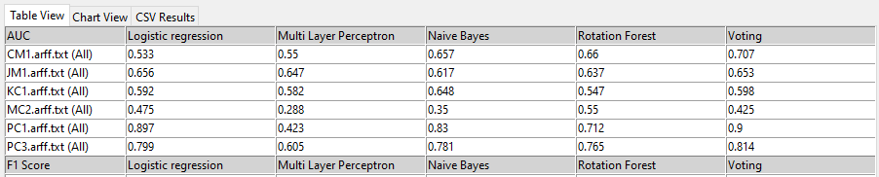

(Results 1)

